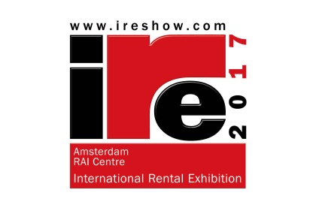
PRESS RELEASE

January 2017

The International Rental Exhibition (IRE) is sold-out

Almost 60 manufacturers and suppliers to the rental industry have signed up for the 4th International Rental Exhibition (IRE) in Amsterdam on 2-4 May, 2017. The exhibition space is now fully sold-out, and more than 65 brands of equipment will be on display.

IRE takes place at the Amsterdam RAI centre alongside three other rental-related events; the APEX access equipment show, the European Rental Association’s annual convention, and the European Rental Awards dinner.

IRE will be a showcase for products and services targeted at equipment rental companies. Among the exhibitors will be 13 compact earthmoving and compaction equipment suppliers; 14 lighting tower manufacturers; 10 genset specialists; and seven rental software and IT companies.

Global suppliers attending include JCB, Hitachi, Caterpillar, Ammann, Case Construction, Atlas Copco Portable Energy, Volvo Construction Equipment, Wacker Neuson, Ditch Witch, Vermeer, Thwaites and Yanmar Construction Equipment Europe.

First-time exhibitors include Spanish genset supplier AEM SL, new Italian lighting tower producer Trime, Beton Trowel, Case Construction, Elentek, Euro Towers, Gölz, Inmesol, Kärcher, Legend Brands Europe (Dri-Eaz), MASE Generators, MCS (Master Climate Control), Mtools (Makinex), NJ Fromont, Perkins, Tobrocco (Giant skid steers) and TSR-Lighting.

The full list of exhibitors can be found at www.IREshow.com

Tony Kenter, Managing Director of show organiser Industrial Promotions International (I.P.I.), said; “Selling out the show before the end of the 2016, and five months in advance, is fantastic news.

“Visitors to IRE will enjoy a unique event, with free access to the adjoining APEX aerial platform exhibition. This means that visitors will be able to see, under one roof, a remarkable range of rental equipment and services, including many of the world’s most important suppliers.

“The European Rental Association will also hold its important annual convention during the three days of the show, which will bring many of Europe’s biggest rental companies to the event, making it the perfect venue for the rental industry to meet, view products and network.”

The exhibition is officially supported by International Rental News and the European Rental Association.

Visitors can register for IRE on the website www.ireshow.com

For information on the ERA convention, visit www.erarental.org

More…
For Editors

For details on the IRE exhibition, see www.ireshow.com

Photos and logos can be downloaded from http://www.khl-group.com/events/IRE-2017/press-area.html

Media Relations:

Han Heilig
BV Industrial Promotions International
Mob: +31 (0) 6532 14 362
Email: han@practica.nl

